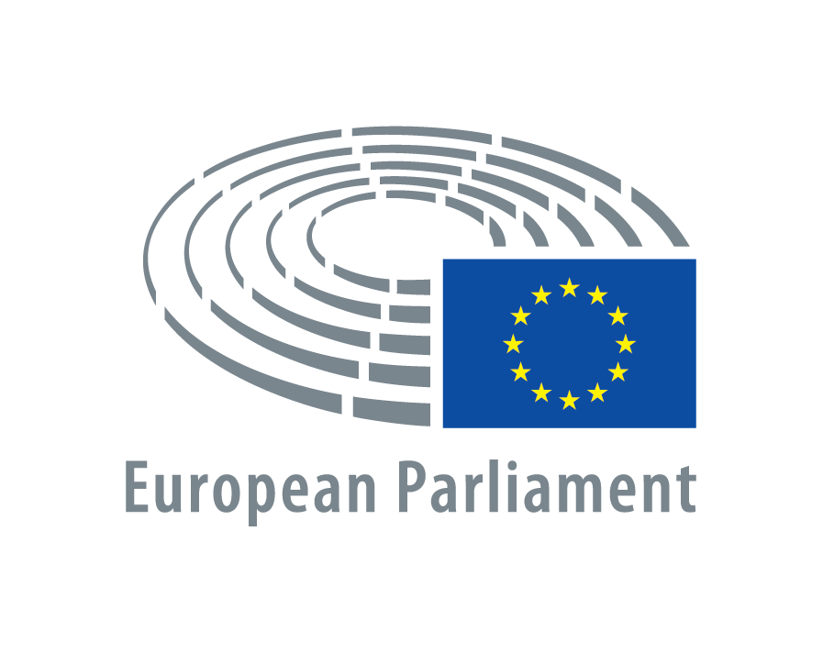

Draft Program Euroscola: 26th of November 2021

Time

9:30 AM |  | Welcoming by the President of the European Parliament,  Mr David Maria SASSOLI  Greetings and introduction to the agenda by the moderators, Ms Stefanie Hintzmann (Arte) and Mr Jakob Groth (Arte)
9:45–  10:30 AM |  | The European Union and its Parliament  Interview with a Vice-President of the European Parliament  Q&A session with the Vice President
10:30-  11:20 AM |  | Innovation labs:  Climate change and the environment: how can we live in harmony with nature?  - Intervention by Mr Giacomo FASSINA, Secretariat of the committee on the Environment, Public Health and Food of the European Parliament  - Q&A session on: 1) Using resources efficiently for a circular economy, 2) Restoring biodiversity and cutting pollution, 3) Creating a global coalition to halt and reverse global warming  - Collection of innovative ideas on the topic: Students are encouraged to formulate claims and present them via chat or live video chat
11:20-  11:30 AM |  | Closing remarks by the Director General for Communication and Spokesperson of the European Parliament,  Mr Jaume DUCH GUILLOT  Wrap up of innovation labs and farewell

